Preface

This tutorial illustrates some of the features you can alter in MuseScore ([www.musescore.com](http://www.musescore.com)) you can alter to produce your own preferred sized and spaced Modified Stave Notation. Once you have made these changes, you can save the format the format by going to Style and then Save Style. You can then use this format for new pieces.

The guide is written by a young pianist who is partially sighted, Rishi Chandarana.

RNIB Music Advisory Service

August 2015

This guide will tell us how to modify pieces of music on Musescore. The piece we will be using for this tutorial is the C minor Prelude by J. S. Bach.

Below are the first few bars in the piece

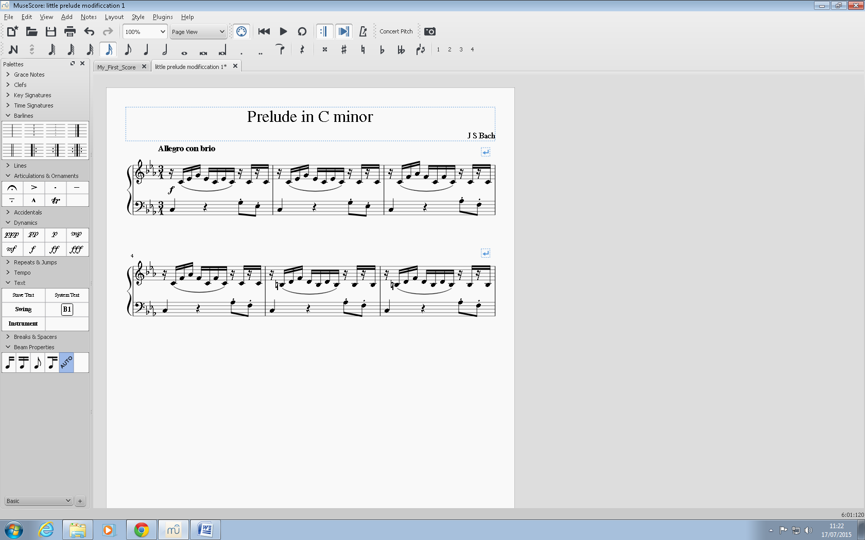

The first step is to select layout in the menu bar and then press page settings

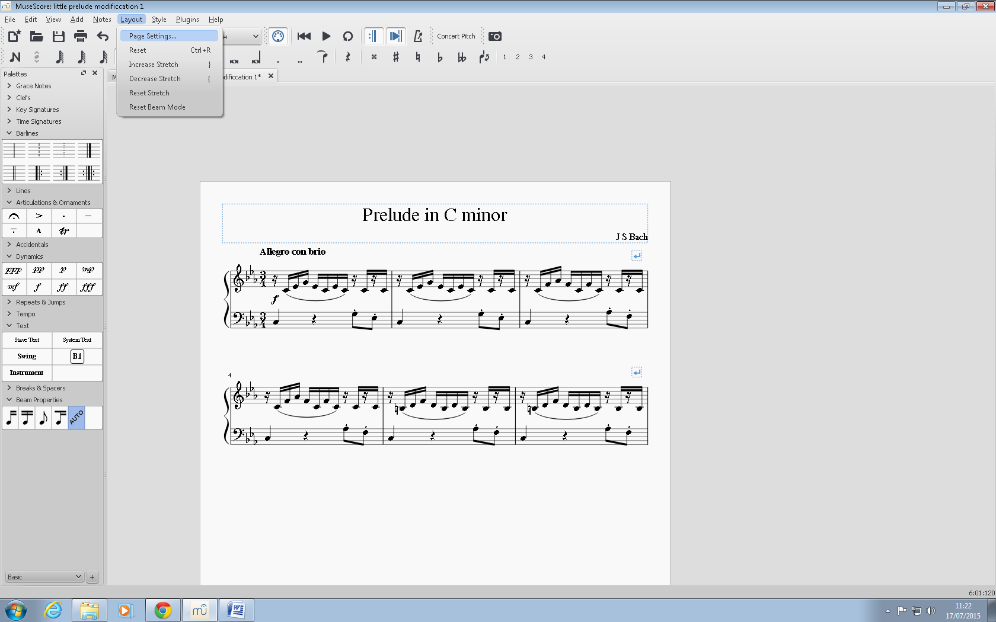

We can then set the margins as wide as possible so we can get as much music on to a page at a time without making it too small.

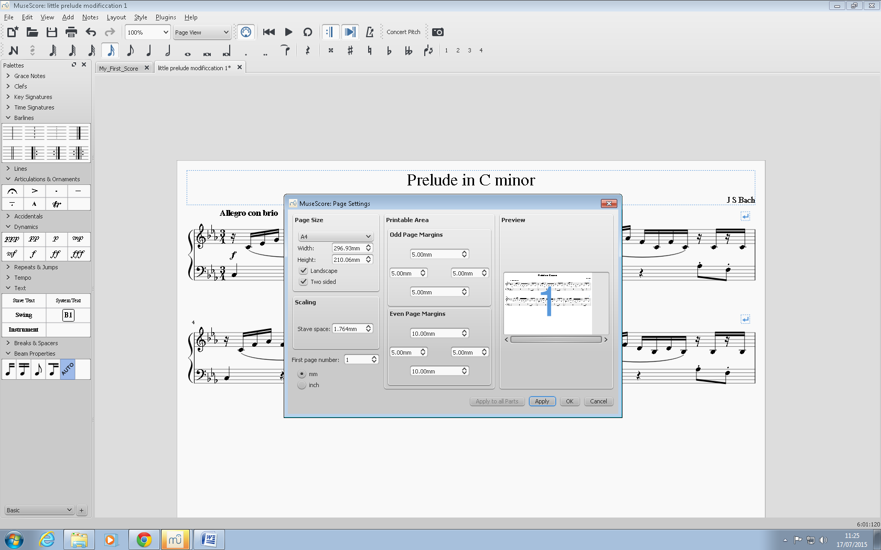

We have now made the margins bigger we have also converted the page’s orientation to landscape so we have reduced the number of systems to track.

Below is the next section of the modification. You go to style and select general.

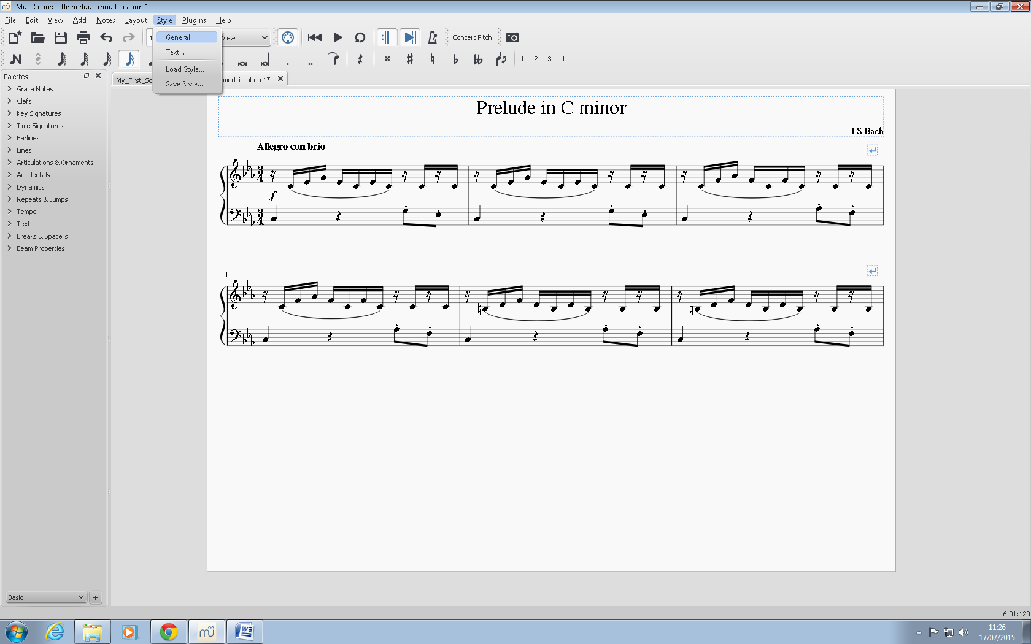

The first place I went to was the heading ‘barlines’.

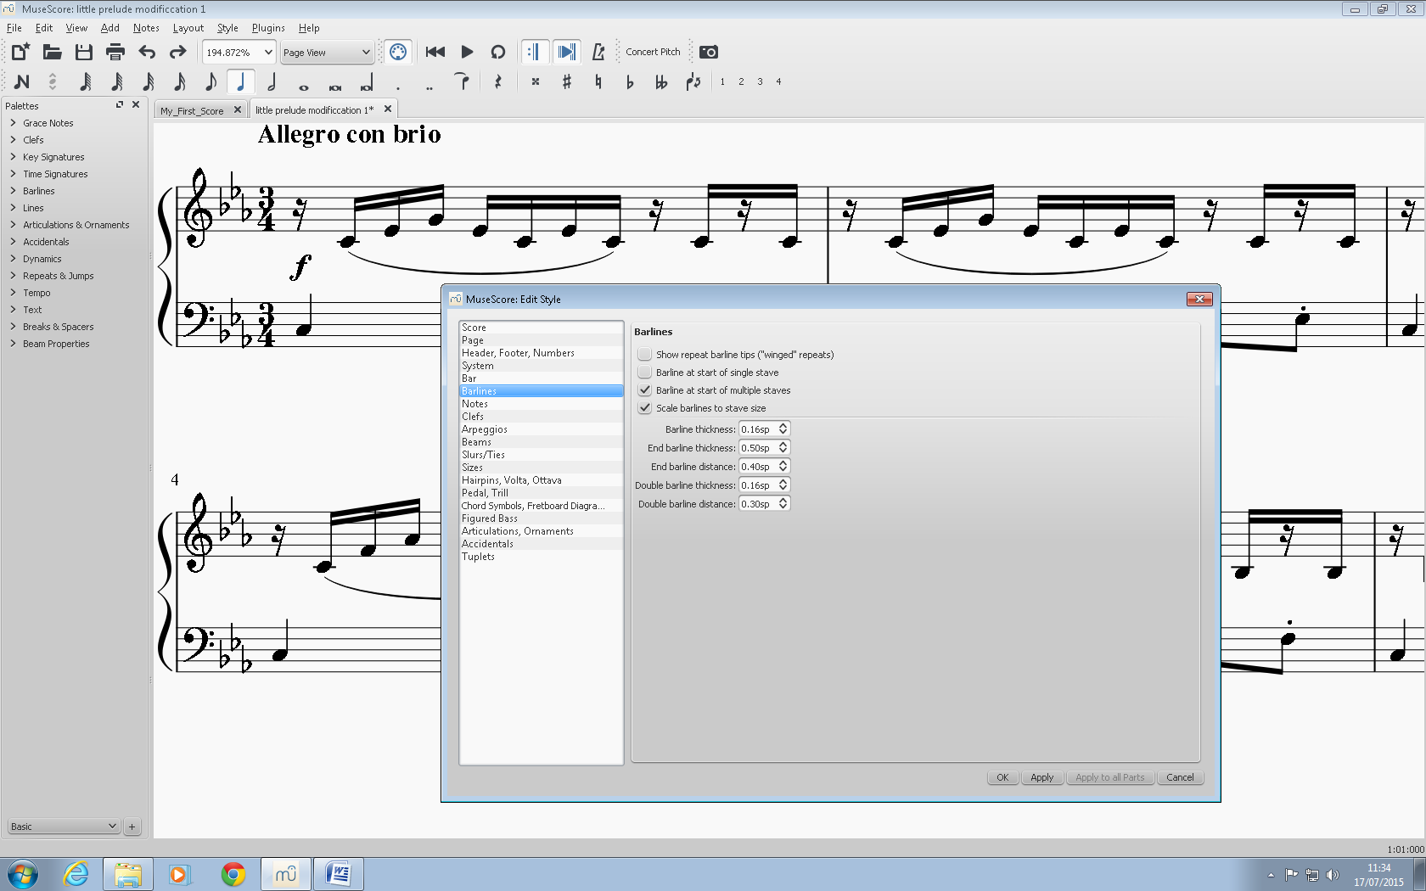

I have organised the page so the first bar line can be seen. The section highlighted in the preferences box controls how thick the bar line is. As you can see from the picture below, I have increased it and the bar line in that picture has gotten thicker

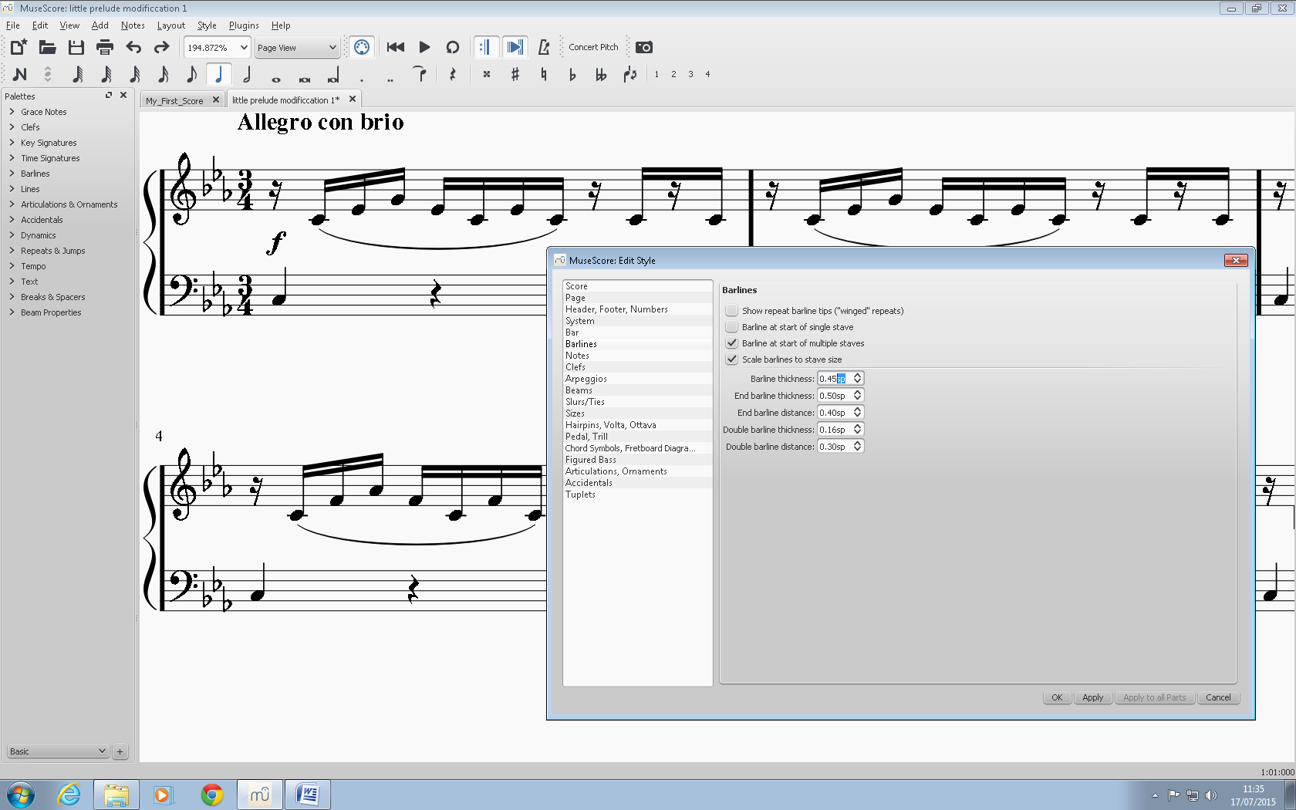

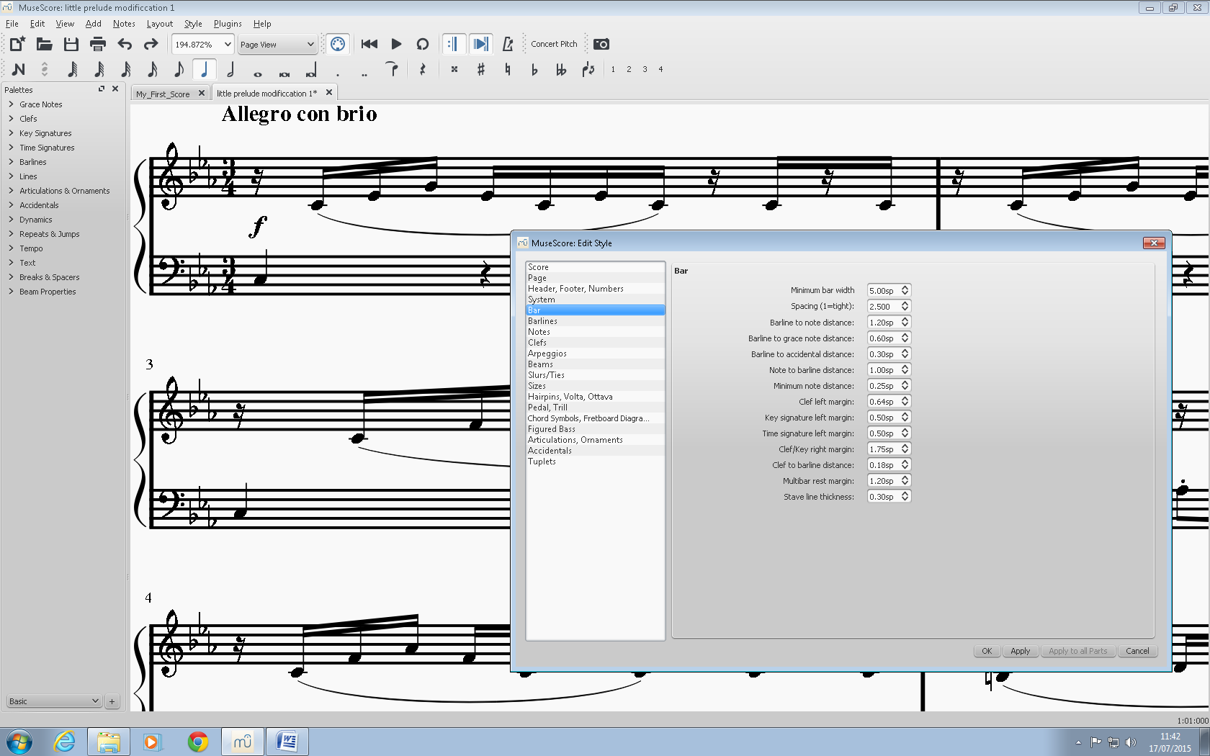

for the next section, I select the Bar section.

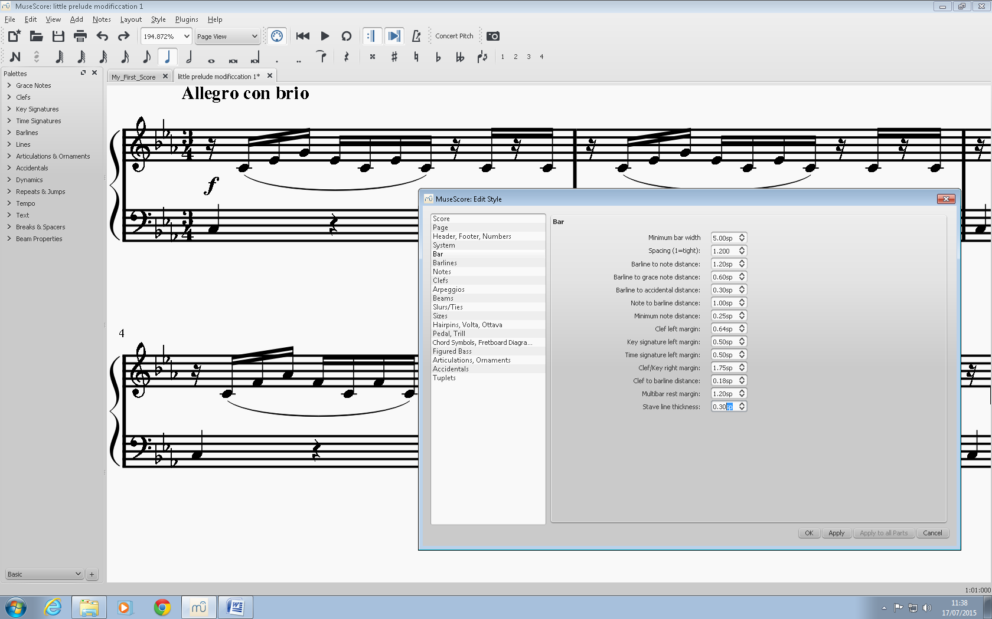

Here, I have changed the stave line thickness so the staves are thicker.

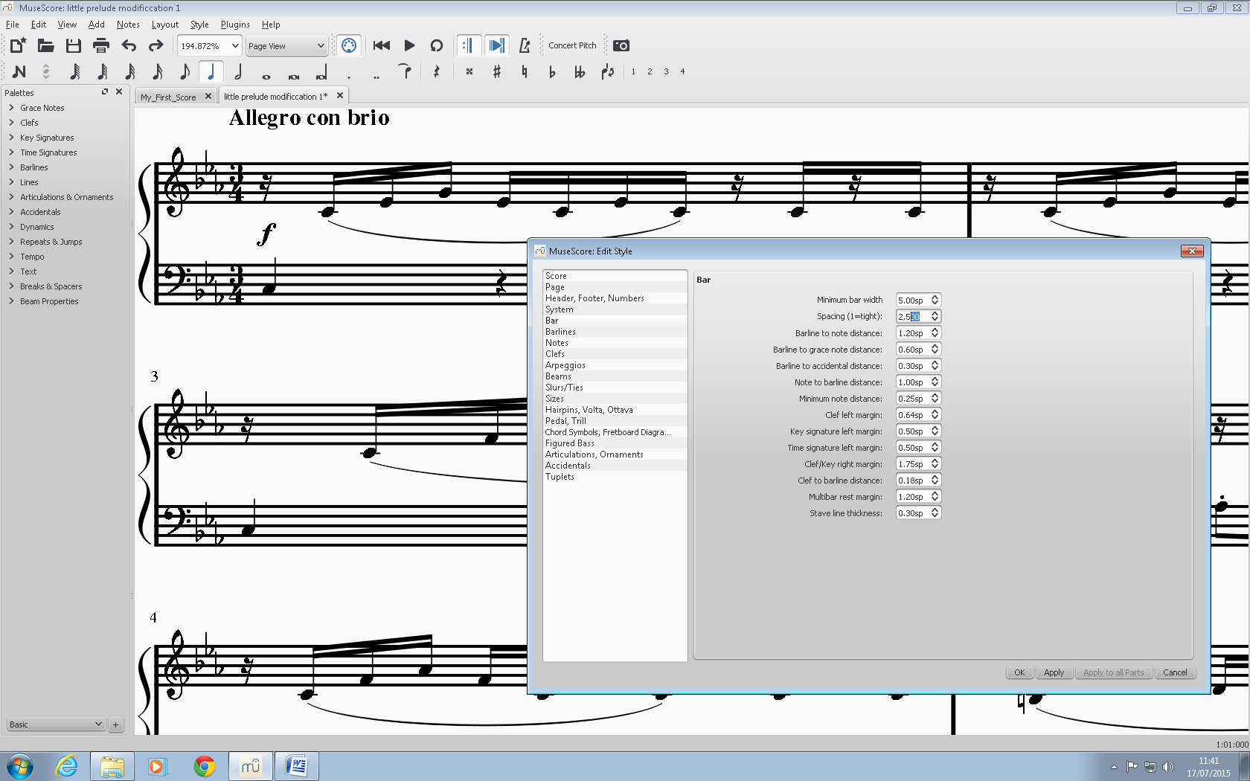

As you can see in the picture above, I have changed the distance between the notes. This gives the reader a clearer image to look at without having to see everything bunched together.

Next I will select the heading, notes.

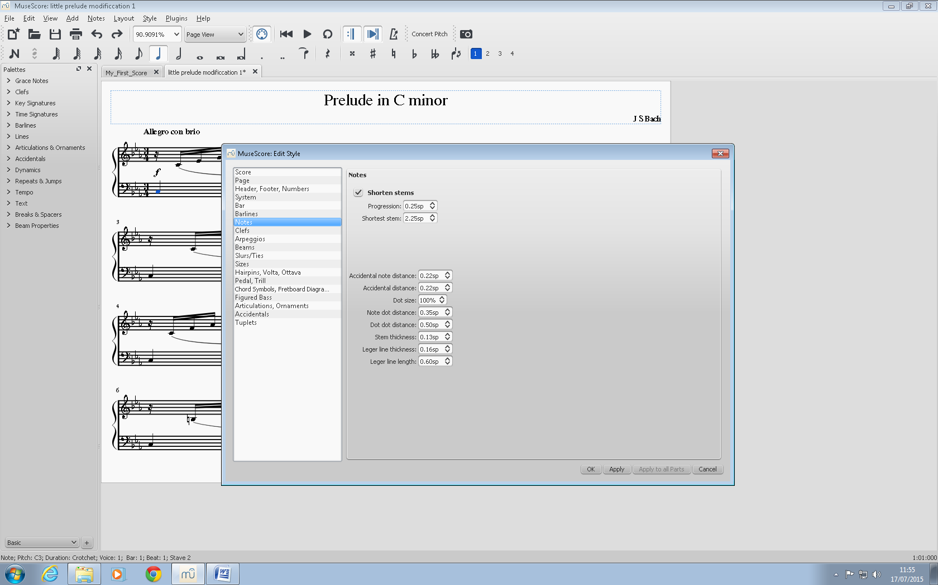

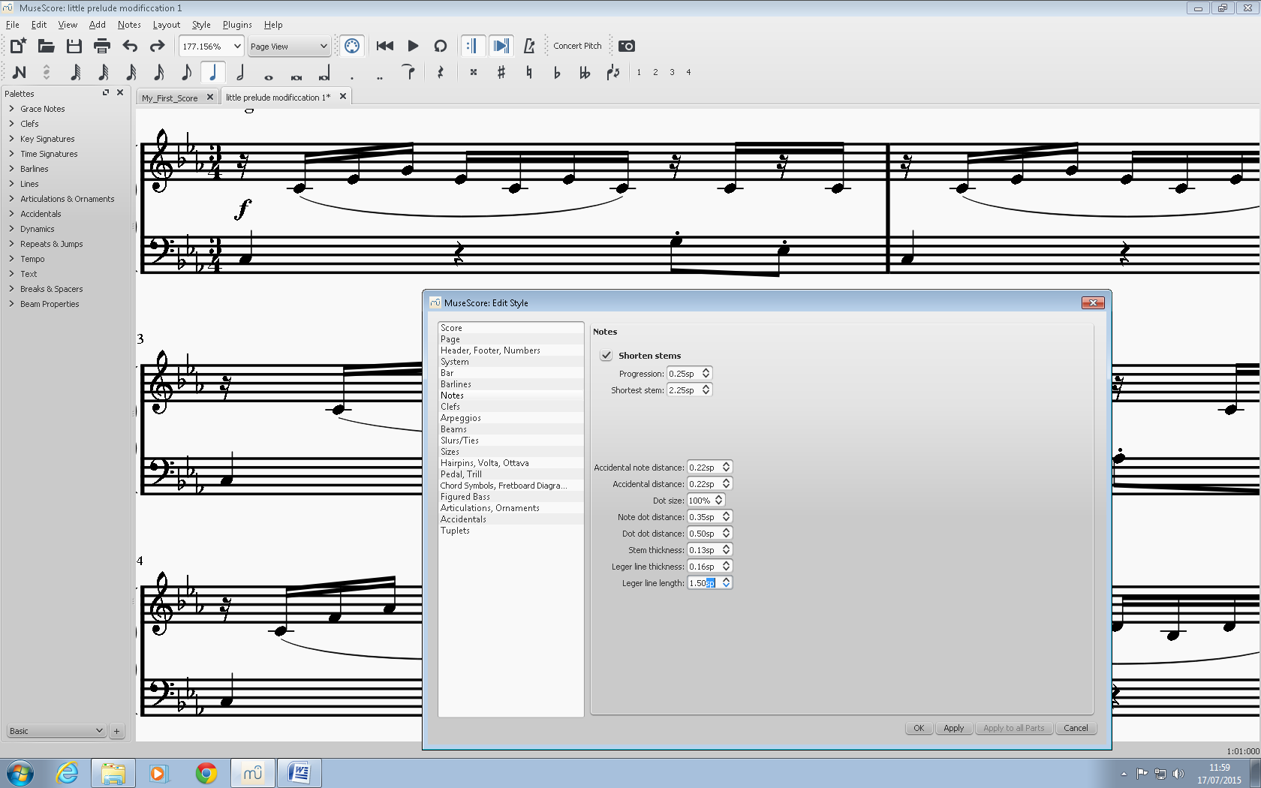

Here, I have changed the length of the ledger lines. I have made them longer so they stand out more. I have made them stand out even more by increasing the thickness of the lines as shown below.

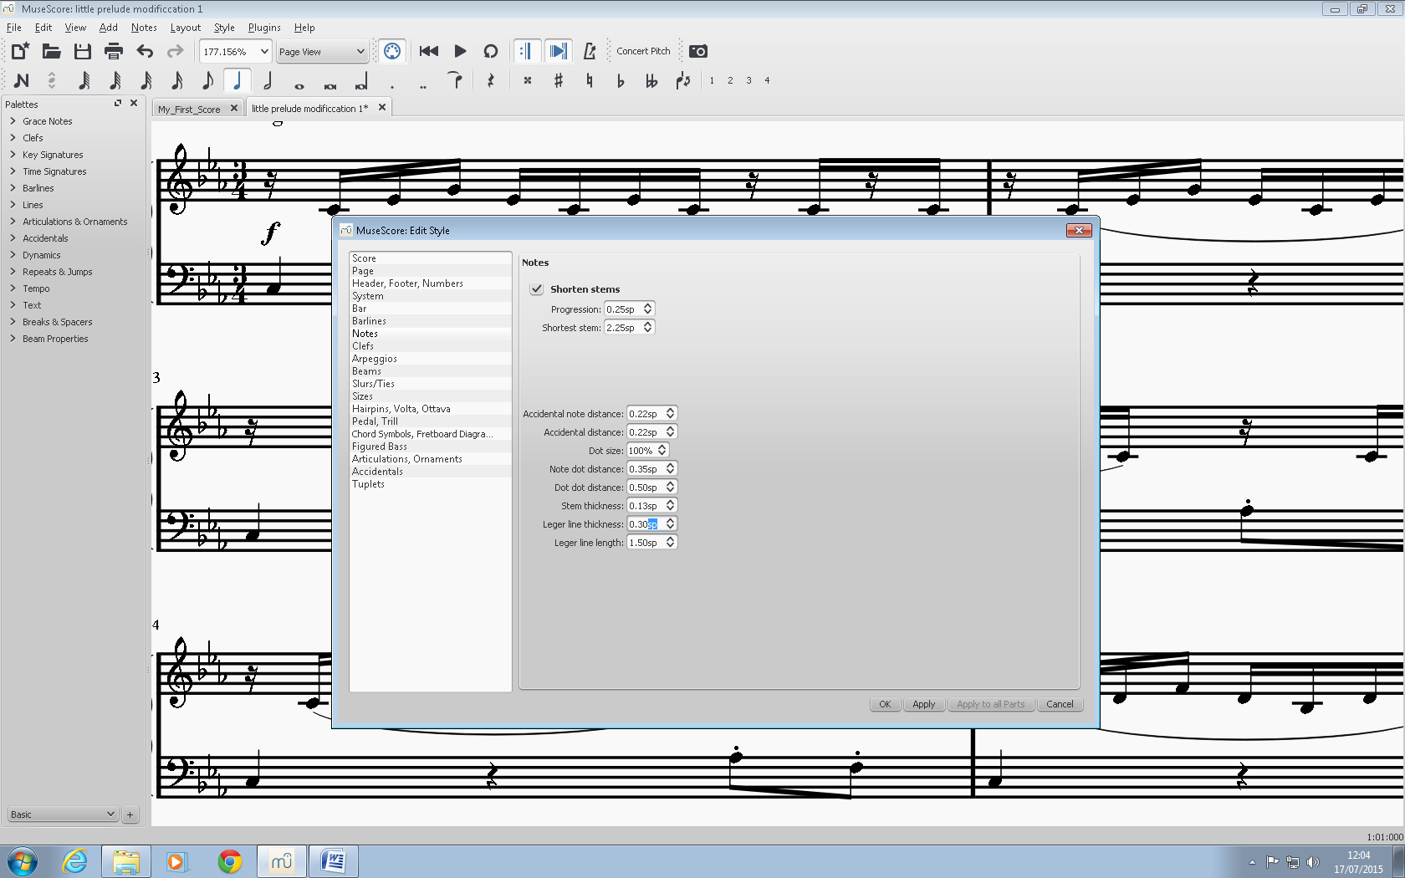

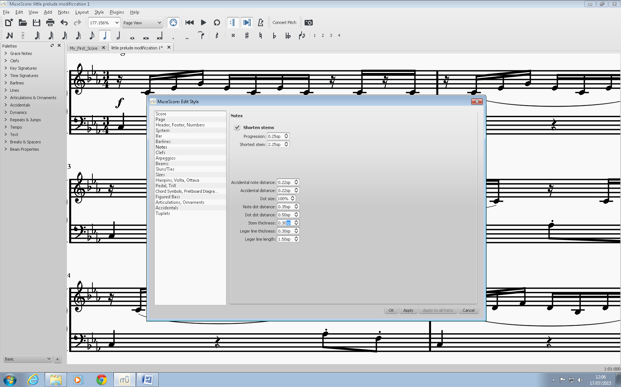

The thickness of the stem of each note has been increased so the reader can see each note a lot clearer.

The next heading to be selected is slurs/ties.

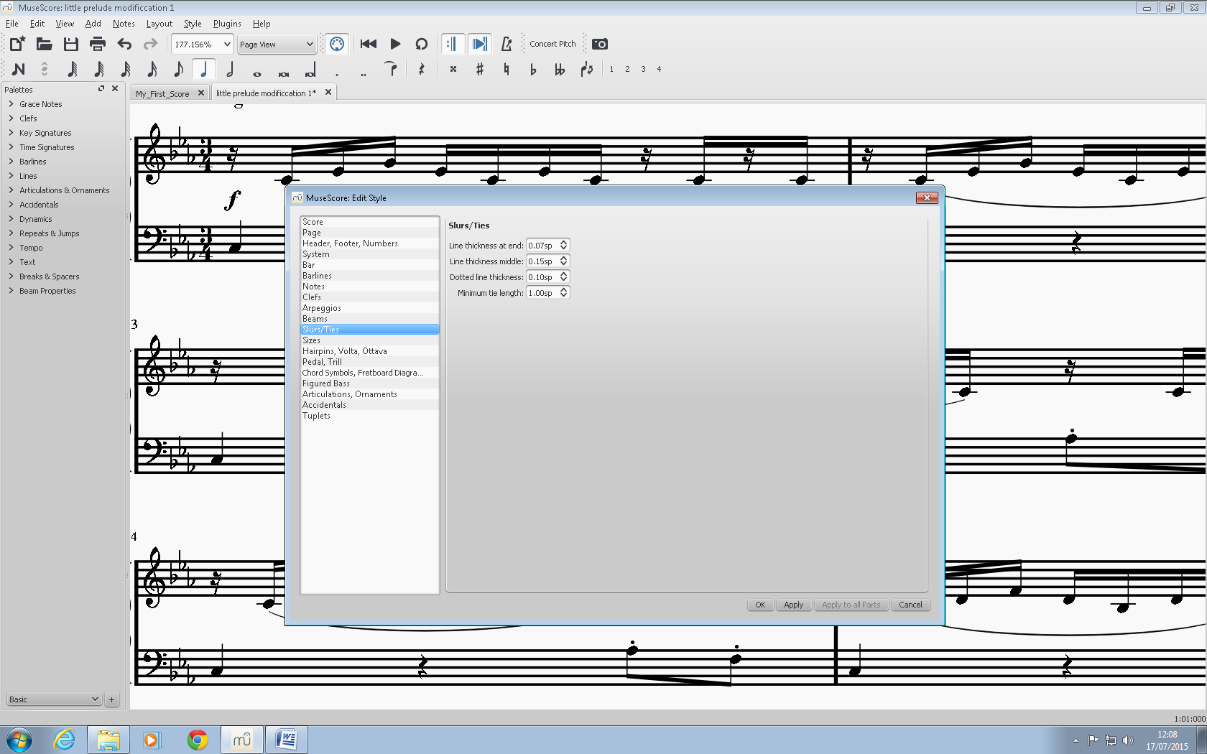

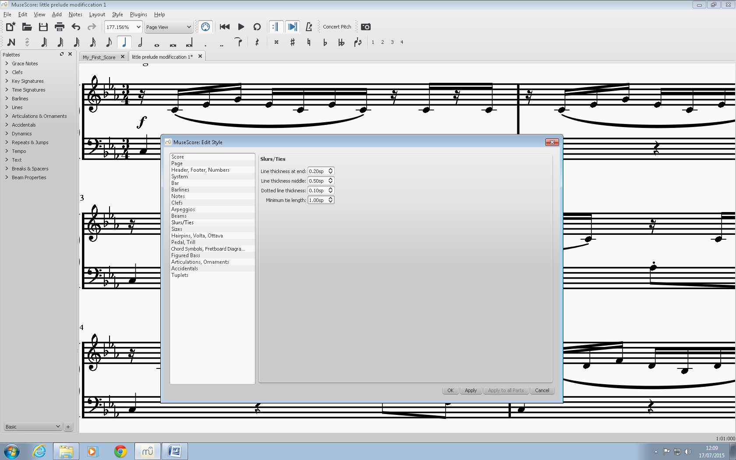

In the picture above, I have changed the thickness at the end and at the middle. As you can see from the first bar, this has made the whole slur thicker. I would advise that you keep the slur at the middle around double the number at the end so that it will be clearly noticeable.

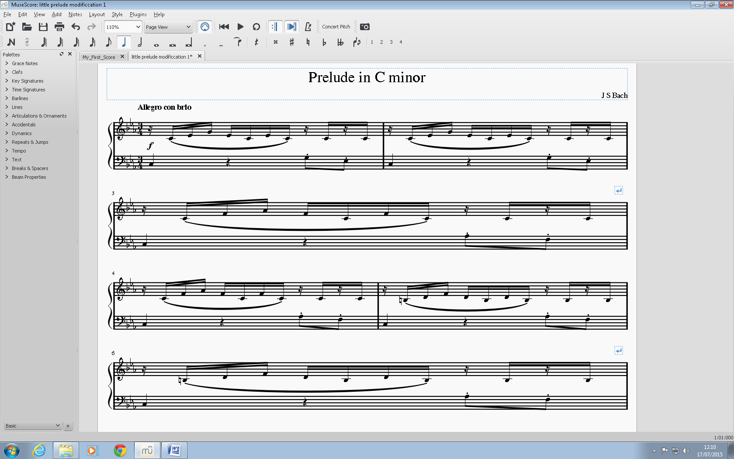

This is the product right now. However it looks a bit cramped. The staves are much too close to each other. To change this, go to layout and select page settings.

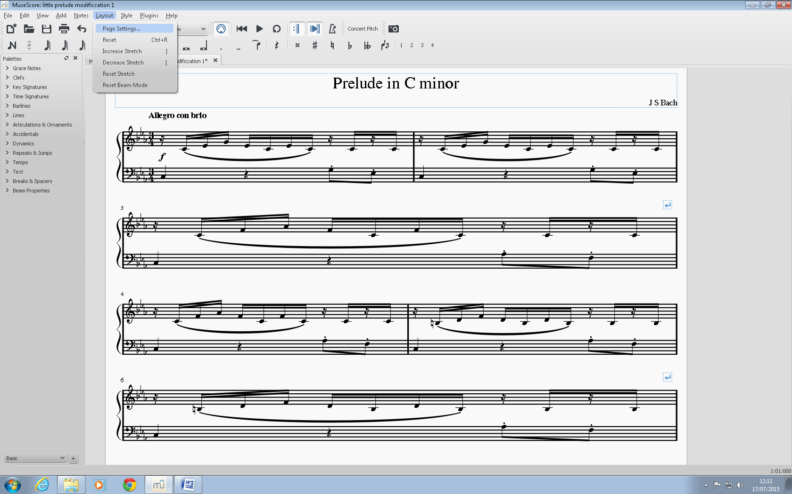

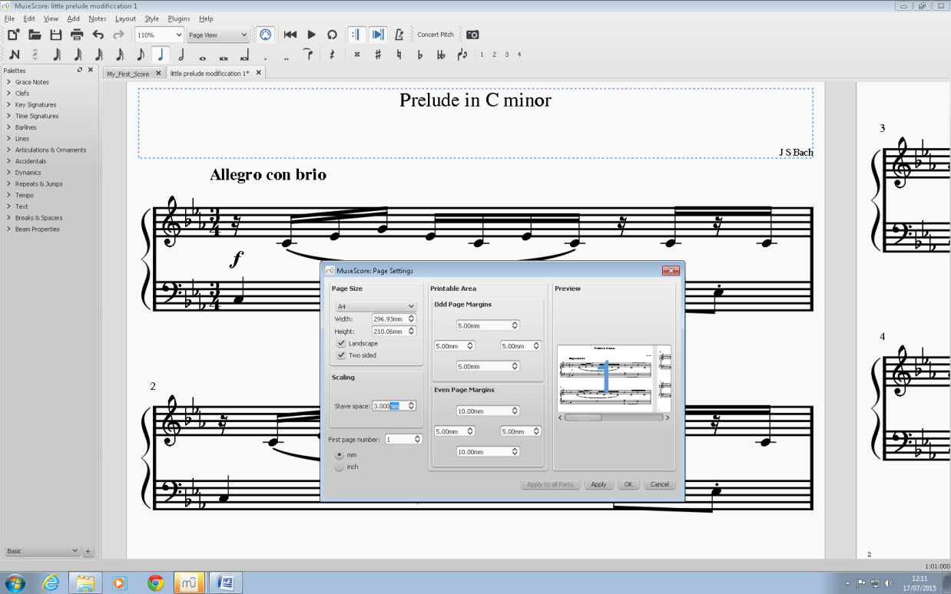

Above, I have increased the stave space. This makes the stave distance bigger and makes the notehead at the end of the stem bigger as well.

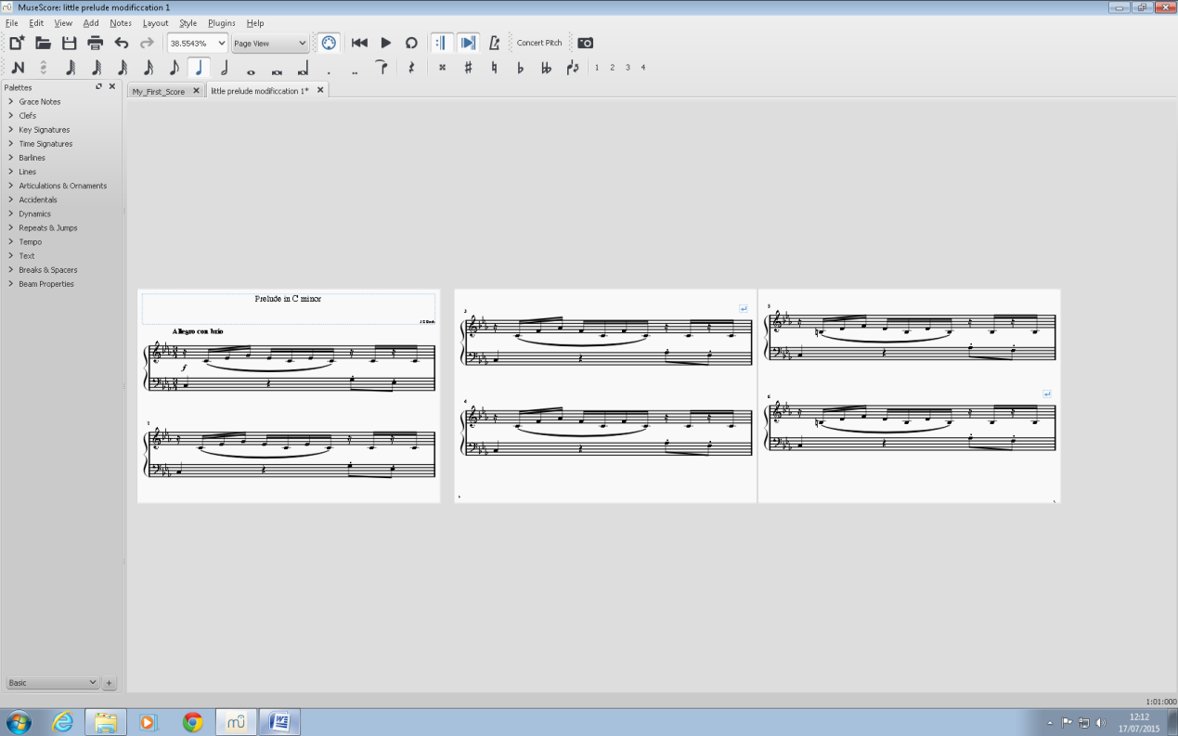This is the final product. If you don’t like the fact that there is one bar per line, you could always change the distance between the notes like shown before to decrease the amount of line space required.

Modifying Text

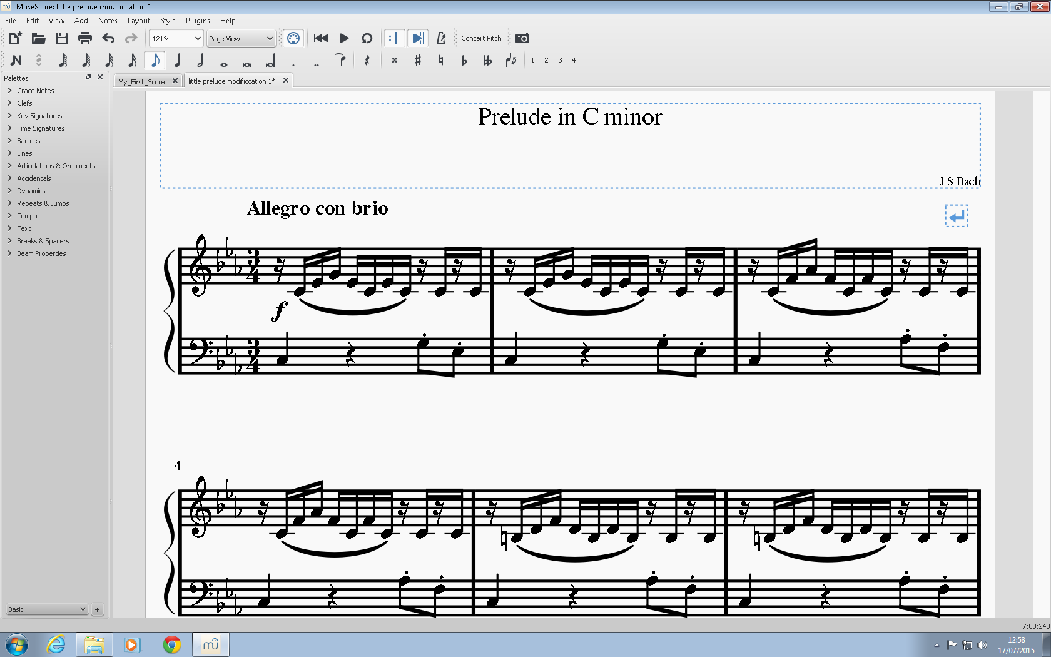

This is a modified version of the music of Bach’s C minor prelude. I am going to show you how to edit the text in this piece.

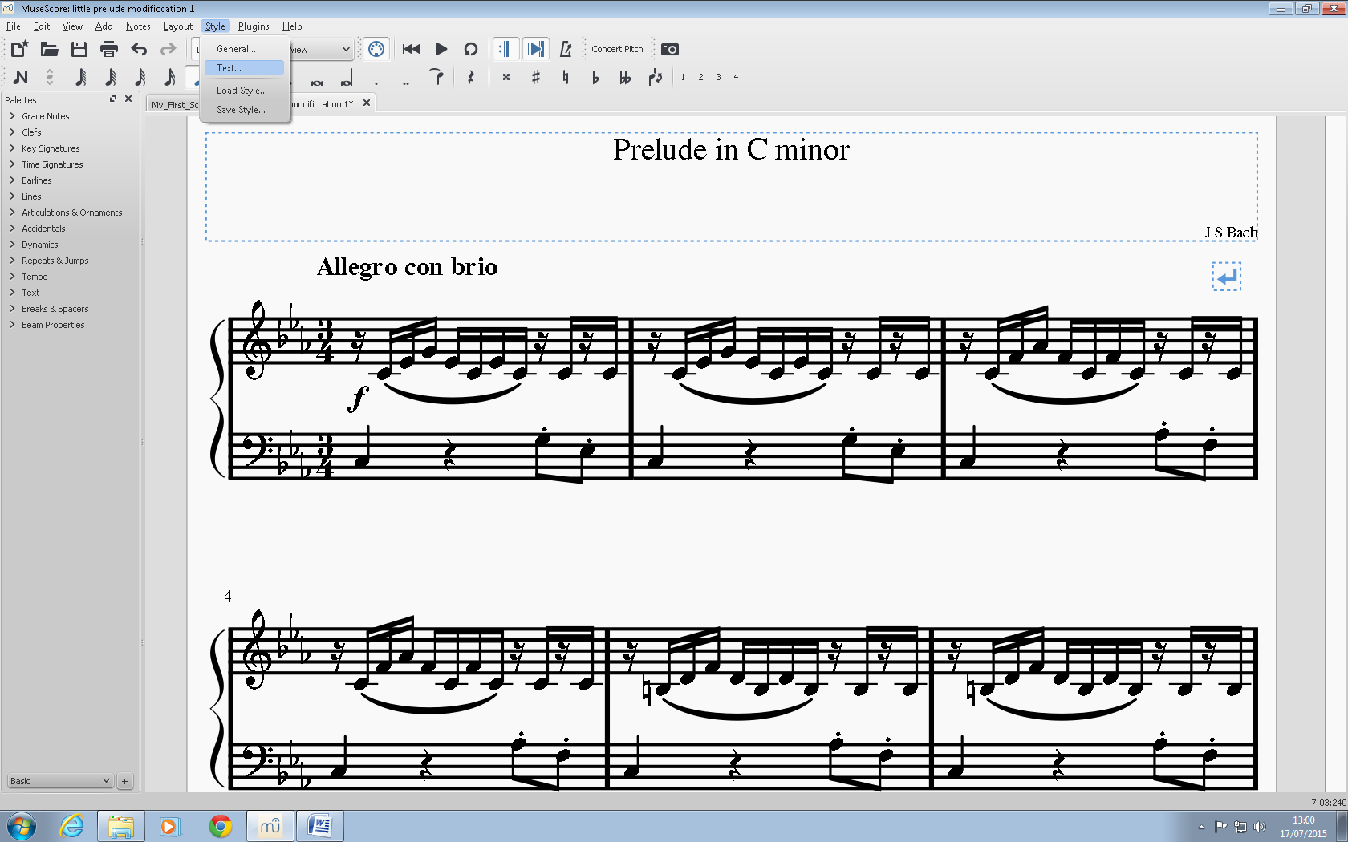

Firstly you go to the style menu and select text.

The features for each heading are exactly the same so I am going to show you how to do the title.

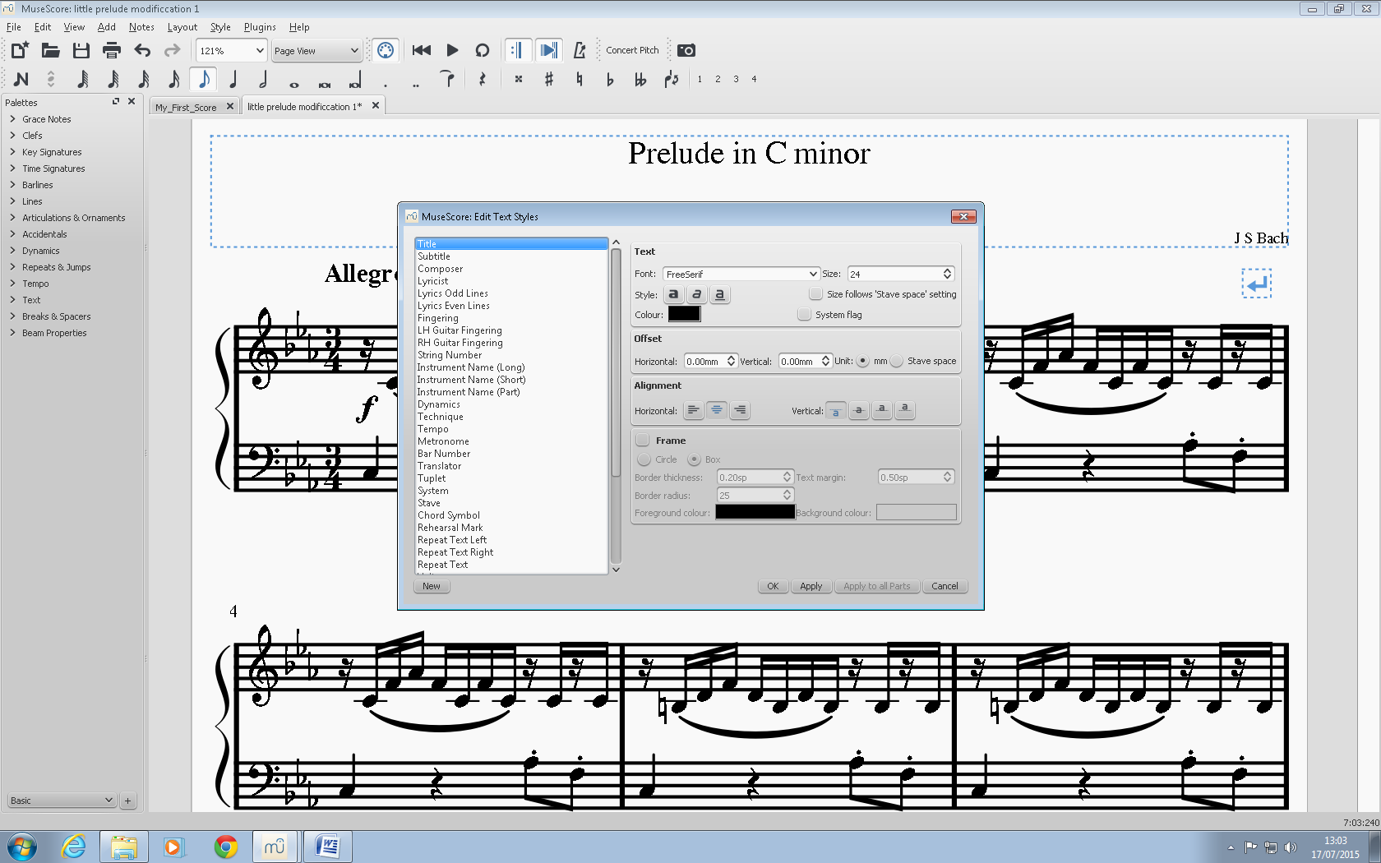

I have changed the font of the title to Arial Black (the same font I am using in this text) as it is large and bold which is easier to see compared to others.

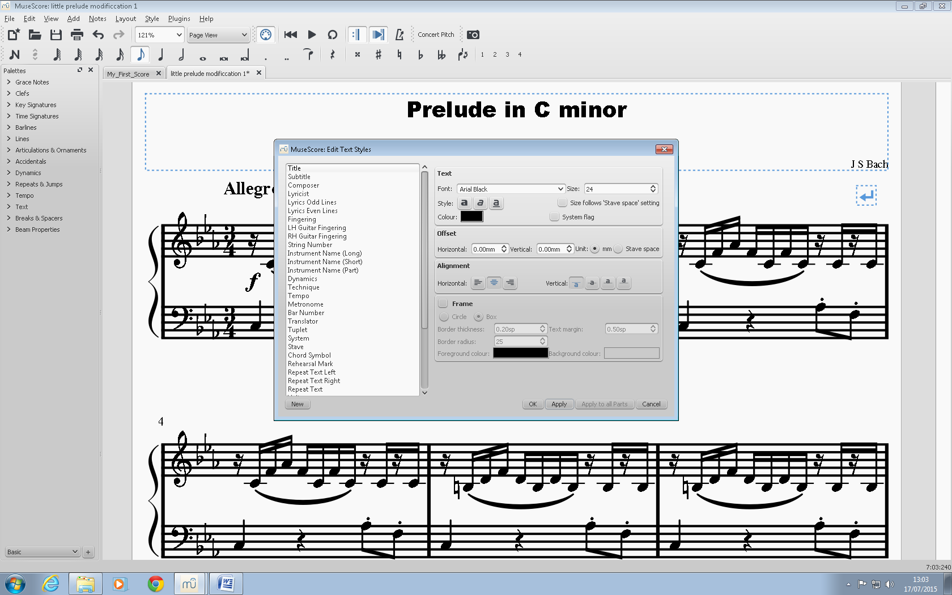

At the top of the box are the font options which allow you to change the text size and style. That is all you really need to make the text easy to read for all of the headings.

Rishi Chandarana

July 2015